Name: A.Reddy Sulochana
Reg.No: 192372370

Exp.No.10 A* Algorithm
01.08.26

Aim:
To implement the A* (A-Star) search algorithm in Python to find the shortest path between a start node and a goal node.

Algorithm:
- Start the program.
- Define the graph with nodes and edge costs.
- Define the heuristic value for each node.
- Initialize the open list with the start node.
- Initialize the closed list as empty.
- Select the node with the lowest f(n) = g(n) + h(n) value.
- If the selected node is the goal node, display the path and stop.
- Otherwise, expand its neighbouring nodes and update their costs.
- Repeat Steps 6–8 until the goal is reached or no path exists.
- Stop the program.

Program:
graph = {
'A': [('B', 1), ('C', 3)],
'B': [('D', 3), ('E', 1)],
'C': [('F', 5)],
'D': [('G', 2)],
'E': [('G', 4)],
'F': [('G', 1)],
'G': []}
heuristic = {
'A': 6,
'B': 4,
'C': 4,
'D': 2,
'E': 2,
'F': 1,
'G': 0}
def a_star(start, goal):
open_list = [(start, 0)]
g_cost = {start: 0}
parent = {start: None}
while open_list:
open_list.sort(key=lambda x: x[1] + heuristic[x[0]])
current, _ = open_list.pop(0)
if current == goal:
path = []
while current:
path.append(current)
current = parent[current]
path.reverse()
return path
for neighbour, cost in graph[current]:
new_cost = g_cost[current] + cost
if neighbour not in g_cost or new_cost < g_cost[neighbour]:
g_cost[neighbour] = new_cost
parent[neighbour] = current
open_list.append((neighbour, new_cost))
return None
start = input("Enter start node: ")
goal = input("Enter goal node: ")
path = a_star(start, goal)
if path:
print("Shortest Path:", " -> ".join(path))
else:
print("No path found.")

Input:
Enter start node: A
Enter goal node: G
Output: 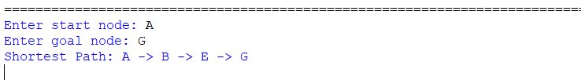

Result:
Thus, the Python program to implement the A* search algorithm was executed successfully, and the shortest path from the start node to the goal node was obtained.

